**Technical Report for Database Management Systems Semester Project**

**Meghan Fleischman**

**Aaron Davis**

**Team 11**

**System Design**

When designing our version of MeTube we started by creating something similar to a basic class diagram as a rough draft of our database. Since it was more of a class diagram it also outlined a few functions we knew needed to be implemented to carry out functions meant for the website. Naturally, since this was a draft there have been numerous modifications to the material since. At the time this was done based on YouTube as a model, so the contact and messages features were not yet present. The figure below is that exact diagram. (Note that this was before ER Diagrams were introduced in class.)

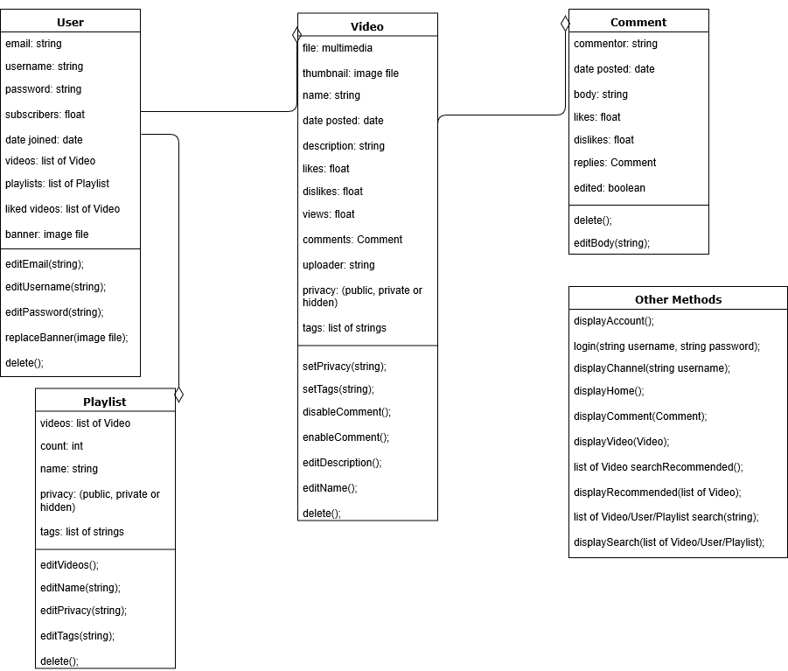

Once coding began in order to get a better understanding of what php functions would be required the basic web pages were created such as the home page, account page, search page, sign in and account creation page. From there we created any other pages that would accompany them until the navigation of our website worked as the diagram below shows.

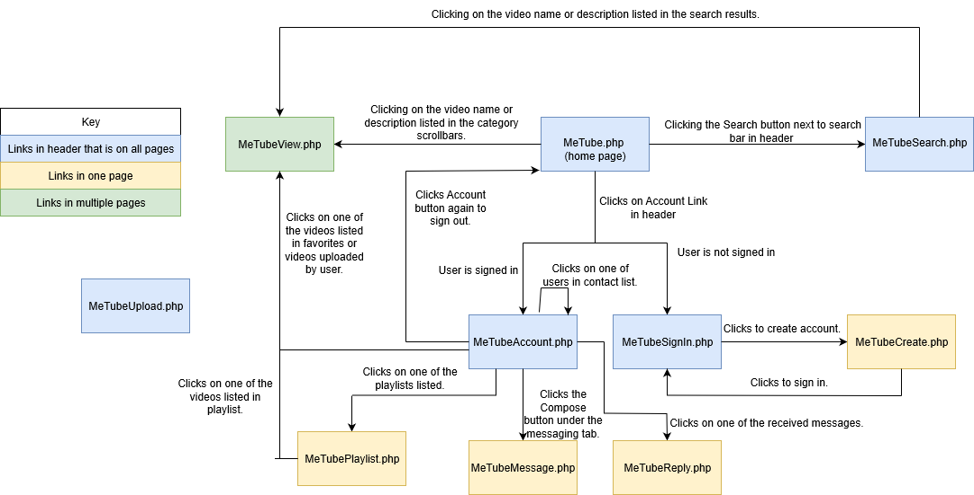

Note that the web pages are all listed as php pages, however they are all written in html5 format. As php files the file can be used with an action. For example, the Search button uses the form function to send the user to the MeTubeSearch.php as an action. There are also pages with html coding not shown in the diagram above. One of which is the global header php file. This basically makes the MeTube logo, search bar and account button show up on every page. Following the instructions on the flowchart above, one can navigate the majority of the website.

For the database we relied partially on the class diagram shown previously, but a few changes were made since we now knew the basics of standard database tables. Our table with the revised database schema is shown below. Things like the privacy variable and the thumbnail were cut out during development. The database was built using phpMyAdmin.

|  |  |  |  |
| --- | --- | --- | --- |
| Media | id | INT unsigned NOT NULL AUTO_INCREMENT | PRIMARY KEY id |
| userid | int | Users: id |
| type | string |  |
| title |  |
| description |  |
| category |  |
| Users | id | INT unsigned NOT NULL AUTO_INCREMENT | PRIMARY KEY id |
| name | VARCHAR(50) NOT NULL |  |
| password | VARCHAR(100) NOT NULL |  |
| description | VARCHAR(2000) NOT NULL |  |
| Comments | id | int |  |
| mediaid | Media: id |
| userid | Users: id |
| text | string |  |
| Messages | id | int |  |
| recvid | Users: id |
| sendid | Users:id |
| text | string |  |
| MediaTags | mediaid | int | Media: id |
| tag |  |
| Playlists | id | int | PRIMARY KEY id |
| userid | Users: id |
| Favorites | mediaid | int | Media: id |
| userid | Users: id |
| UserContacts | userid | int | Users: id |
| contactid | Users: id |
| PlaylistContent | playlistid | int | Playlists: id |
| mediaid | Media: id |

Afterwards, when planning the database design, we created the relational diagram for the database. The diagram mentioned is shown below. As it can be seen there are three primary keys, the ‘id’s for playlists, users and media.

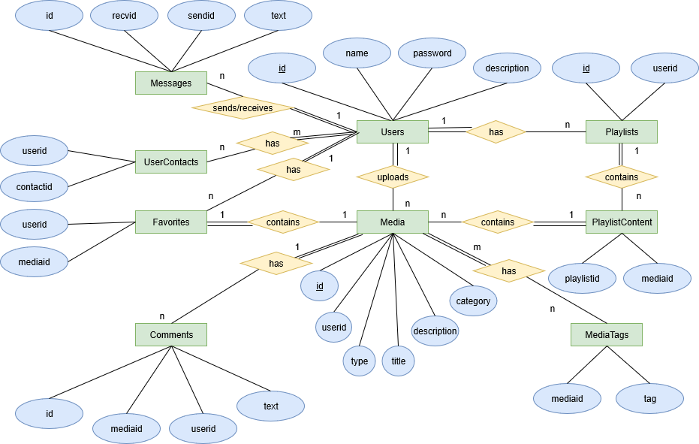

With the database done the php functions needed to be written to integrate the components of the database with the website. Most of the external actions are contained within the operations.php file submitted. This saved time making calls to open the database and other such functions. These are functions from the sign in to account creation and even the playlist creation. This file contains no html code and purely functions to edit the database via the post in forms. Similarly, there is also the function.php file which contains a number of functions used throughout the pages like the one that checks to see if the user is logged in before allowing them to access certain pages. There is also the config.php file that creates variables for the database information and the mysqlClass.inc.php which logs into the server the database is on and establishes a few useful functions for our use.

**Test Cases**

**Users (id is not included since that is hidden from the user):**

|  |  |  |
| --- | --- | --- |
| Name | Password | Description |
| Sally | bubble | Hello, I am Sally. |
| Harry | Egg! | Hello, I am Harry. |
| roger01 | dow. | Hello, I am roger01. |
| Bob | 1233apple | Hello, I am Bob. |
| 320novice | 2138439 | Hello, I am 320novice. |
| ThatKidFromUp | balloons | Hello, I am ThatKidFromUp. |
| Vicky | Crabapple | Hello, I am Vicky. |

**Media (id and type not included since that is hidden from the user, also for legibility. Uploaders name is shown though.):**

|  |  |  |  |  |
| --- | --- | --- | --- | --- |
| Uploader | Title | Description | Description | Category |
| Sally | Myvid | bubble | Hello, I am Sally. | Music |
| Harry | 10 seconds | Egg! | Hello, I am Harry. | Entertainment |
| roger01 | What I think about politics | dow. | Hello, I am roger01. | Politics |
| Bob | category | 1233apple | Hello, I am Bob. | News |
| 320novice | COD montage | 2138439 | Hello, I am 320novice. | Gaming |
| ThatKidFromUp | Hello, MeTube | balloons | Hello, I am ThatKidFromUp. | Sports |
| ThatKidFromUp | ThatKidFromUp here! | Crabapple | Hello, I am Vicky. | Sports |

**Playlists (used username instead of id again.):**

|  |  |
| --- | --- |
| Name | playlistid |
| ThatKidFromUp | 0 |
| ThatKidFromUp | 1 |
| Bob | 2 |

**PlaylistContent (used media name instead of id for legibility.):**

|  |  |
| --- | --- |
| Media title | playlistid |
| Hello, MeTube | 0 |
| ThatKidFromUp here! | 0 |
| 10 seconds | 1 |
| What I think about politics | 2 |

**Comments (used username and media title for legibility. Content id excluded):**

|  |  |  |
| --- | --- | --- |
| Username | Media title | Text |
| ThatKidFromUp | ThatKidFromUp here! | If I could like my own comment I would. |
| Sally | ThatKidFromUp here! | Nice vid! |
| Harry | COD montage | Terrible background music. Unsubscribing. |

**UserContacts (used usernames for legibility.):**

|  |  |
| --- | --- |
| username | contactname |
| ThatKidFromUp | Harry |
| ThatKidFromUp | Sally |
| Sally | Bob |
| Bob | Sally |

**Favorites (uses the names and titles instead of ids for legibility.):**

|  |  |
| --- | --- |
| username | Media title |
| ThatKidFromUp | ThatKidFromUp here! |
| ThatKidFromUp | Hello, MeTube |
| ThatKidFromUp | COD montage |
| Sally | ThatKidFromUp here! |
| roger01 | category |

**MediaTags (uses the media title instead of id for legibility.):**

|  |  |
| --- | --- |
| Media title | tag |
| ThatKidFromUp here! | 1 |
| ThatKidFromUp here! | 2 |
| category | 1 |
| COD montage | 35 |